MACH4METAL

metalworking machinery
Transito 21, 6909 DA Babberich, Netherlands
Tel. + 31 (0)316 – 247123
Fax. + 31 (0)316 - 247956
info@mach4metal.com
www.mach4metal.com
Bank No : 66.52.13.883
IBAN : NL33 INGB 0665 2138 83
BIC : INGBNL2A
VAT : NL 815393635B01

MAZAK SLANT TURN 60N

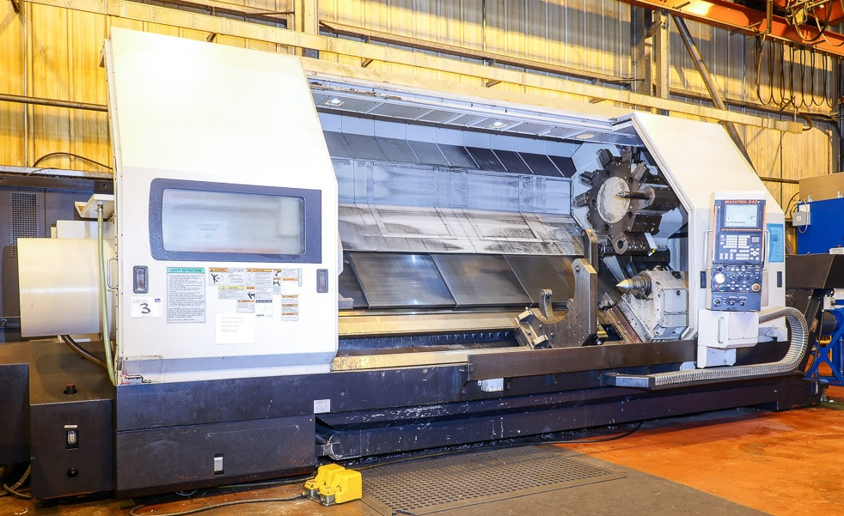
- Make : MAZAK - YAMAZAKI
- Typ : SLANT TURN 60 N
- Age : 08 . 2007
- Serial : 195192

- Swing over bed : 915
- Swing over slide : 685
- DBC turning length : 3.225
- Spindle bore : 100
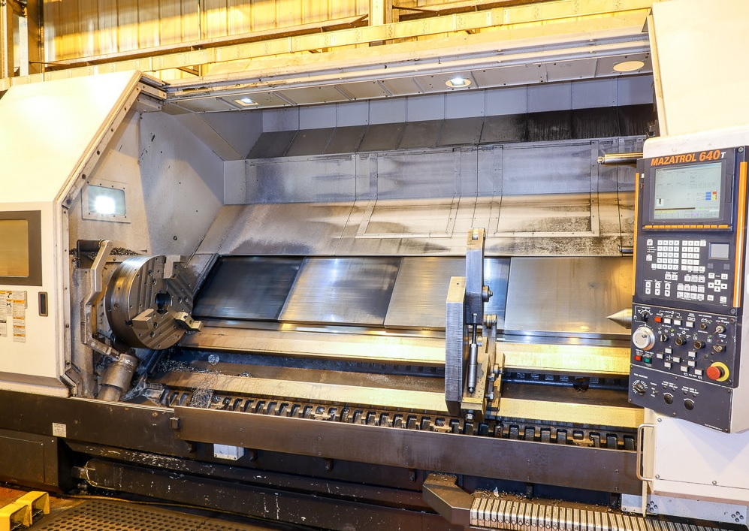
- Work load in chuck : 1.000
- Work between centre : 3.000

- Turret revolver : 15 Positions
- Number tools : 10 outside + 5 inside

- Quill diameter : 180
- Quill stroke : 160
- Taper : Mk 6
- Stroke tailstock : 2.810
- Spindle main power Kw : 45 kW
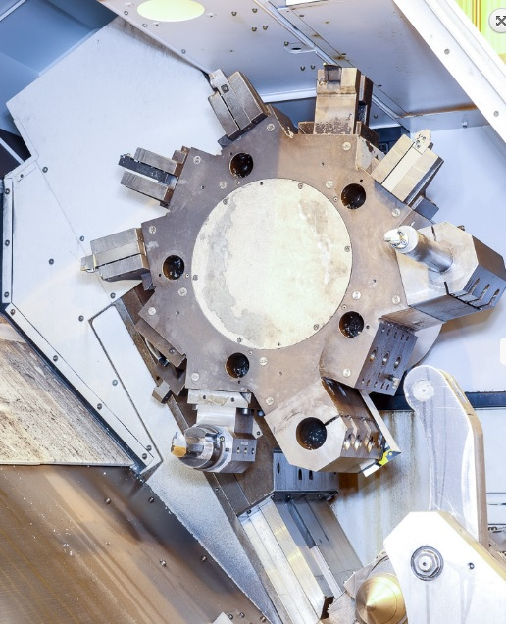
- Dimensions
- Length :
- Width :
- Height :

- MAZATROL FUSION 640 CNC
- 2 x Telbrook steady rest Ø 100 – 300
- Tool eye
- Chip conveyor
- Package with tool holders

Please Note: The above information has been obtained to the best of our ability and belief from, and from the manufacturers where possible. It is given in good faith, but its accuracy can not be guaranteed. Accordingly, it will not form a representation or constitute contractual terms. We advise you to check any vital details!

